BOYS’ UNIFORM REQUIREMENTS
Grades Kindergarten through 8

FALL/SUMMER:
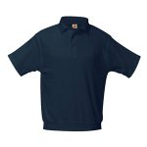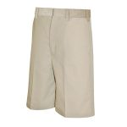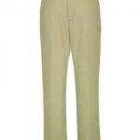

NAVY, SHORT SLEEVE, BANDED-BOTTOM POLO (WITH LOGO)
Your school uniform will always look neat with our tidy banded bottom polo shirt. Our polyester / cotton blend shirt is guaranteed NOT to shrink wash after wash.
Machine Wash Warm. Tumble Dry Low. Remove Promptly. Do not Iron Decoration.

KHAKI WALKING SHORTS
The updated styling of our Boy’s brushed twill flat front shorts combines the luxury of cotton with the strength of Polyester. Sizes 4-12 and all Husky sizes come with an additional 1″ growth elastic.
Machine Wash Warm. Do not Bleach. Tumble Dry Low. Remove Promptly. Cool Iron.

KHAKI TWILL PANTS
The updated styling of our Boy’s brushed twill flat front pants combines the benefits of cotton with the durability of Polyester. Sizes 4-12, and all Husky sizes come with an additional 2″” button elastic. All pants have a reinforced double knee. The best wearing and softest uniform pants on the market.
Machine Wash Warm. Do not Bleach. Tumble Dry Low. Remove Promptly. Cool Iron.

WINTER:
Khaki pant. The students may wear the long sleeve navy polo with the school logo or white oxford shirt with the school tie and a navy V-neck sweater/vest.
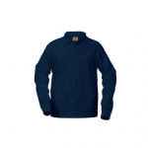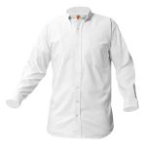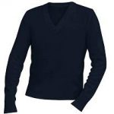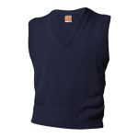

NAVY, LONG SLEEVE, BANDED-BOTTOM POLO (WITH LOGO)
Your school uniform will always look neat with our tidy banded bottom polo shirt. Our polyester / cotton blend shirt is guaranteed NOT to shrink wash after wash. The interlock knit shirt is also pill free!
Machine Wash Warm. Tumble Dry Low. Remove Promptly. Do not Iron Decoration.

KHAKI TWILL PANTS
The updated styling of our Boy’s brushed twill flat front pants combines the benefits of cotton with the durability of Polyester. Sizes 4-12, and all Husky sizes come with an additional 2″” button elastic. All pants have a reinforced double knee. The best wearing and softest uniform pants on the market.
Machine Wash Warm. Do not Bleach. Tumble Dry Low. Remove Promptly. Cool Iron.

WHITE, LONG SLEEVE BUTTON DOWN COLLAR SHIRT
A pleasure to own. The easiest care oxford cloth shirt on the market. Stain Resistant, Wrinkle free shirt lets you wash and wear this shirt with no ironing.
Machine Wash Warm. Tumble Dry Medium. Remove Promptly. Use Warm Iron. Use Non-Chlorine Bleach when Needed.

NAVY, V-NECK PULLOVER SWEATER
Our unisex pill free V-Neck Pullover sweater with reinforced elbows will last for many years. Without question the best uniform sweater on the market.
Machine Wash Warm. Turn Inside Out. Tumble Dry Low. No Bleach.

NAVY, V-NECK SWEATER VEST
Our unisex pill free V-Neck Pullover sweater vest will last for many years. Without question the best uniform sweater vest on the market.
Machine Wash Warm. Turn Inside Out. Tumble Dry Low. No Bleach.

UNIFORM ACCESSORIES
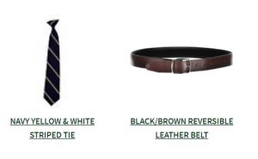

PHYSICAL EDUCATION UNIFORM REQUIREMENTS
Boys & Girls, Pre-Kindergarten Through Eighth Grade
