GIRLS’ UNIFORM REQUIREMENTS

FALL/SUMMER for Girls: kindergarten through 4th grade

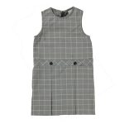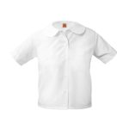

NAVY, WHITE, AND KHAKI GLEN PLAID DROP WAIST JUMPER
Navy, white and khaki glen plaid jumper with a white, short sleeve blouse with a Peter Pan collar.

optional uniform: for fall and summer only

NAVY, SHORT SLEEVE, BANDED-BOTTOM POLO (WITH LOGO)
The optional uniform includes khaki shorts with a short sleeved, navy golf shirt with the school logo. When wearing the jumper students must wear navy knee highs or navy tights. With shorts, the students must wear white socks that cover the ankles.
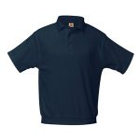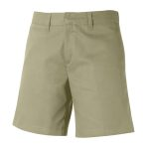
Your school uniform will always look neat with our tidy banded bottom polo shirt. Our polyester / cotton blend shirt is guaranteed NOT to shrink wash after wash.
Machine Wash Warm. Tumble Dry Low. Remove Promptly. Do not Iron Decoration.

The updated styling of our Girl’s brushed twill flat front shorts will make your daughter want to wear her uniform. Sizes 7 and up are in a mid-rise, modern fit. Sizes 4-12, and all Plus size shorts come with an additional 2″ growth feature elastic in the shorts.
Machine Wash Warm. Do not Bleach. Tumble Dry Low. Remove Promptly. Cool Iron.

WINTER Uniform for Girls: Kindergarten- 4th grade

NAVY, WHITE, AND KHAKI GLEN PLAID DROP WAIST JUMPER
Classic drop waist style jumpers with a four kick pleat skirt. This jumper looks great on all shapes and sizes. This jumper is made to last and last.

WHITE, LONG SLEEVE, PETER PAN COLLAR BLOUSE
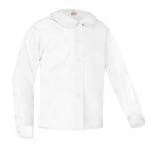
The classic “Peter Pan” school uniform blouse. Looks great with jumpers, shorts and pants.
Machine Wash Warm. Tumble Dry Medium. Remove Promptly. Use Warm Iron. Use Non-Chlorine Bleach when Needed.

NAVY, CREW NECK CARDIGAN
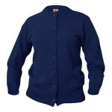
Girl’s pill free button front cardigan with reinforced elbows will last for many years. The perfect sweater for your daughter to wear with a jumper, skirt, pants.
Machine Wash Warm. Turn Inside Out. Tumble Dry Low. No Bleach.

PHYSICAL EDUCATION UNIFORM REQUIREMENTS
Boys & Girls, Pre-Kindergarten Through Eighth Grade
